CO2-AT1
- FIRST AND LAST OCCURRENCE OF AN ELEMENT IN AN ARRAY:
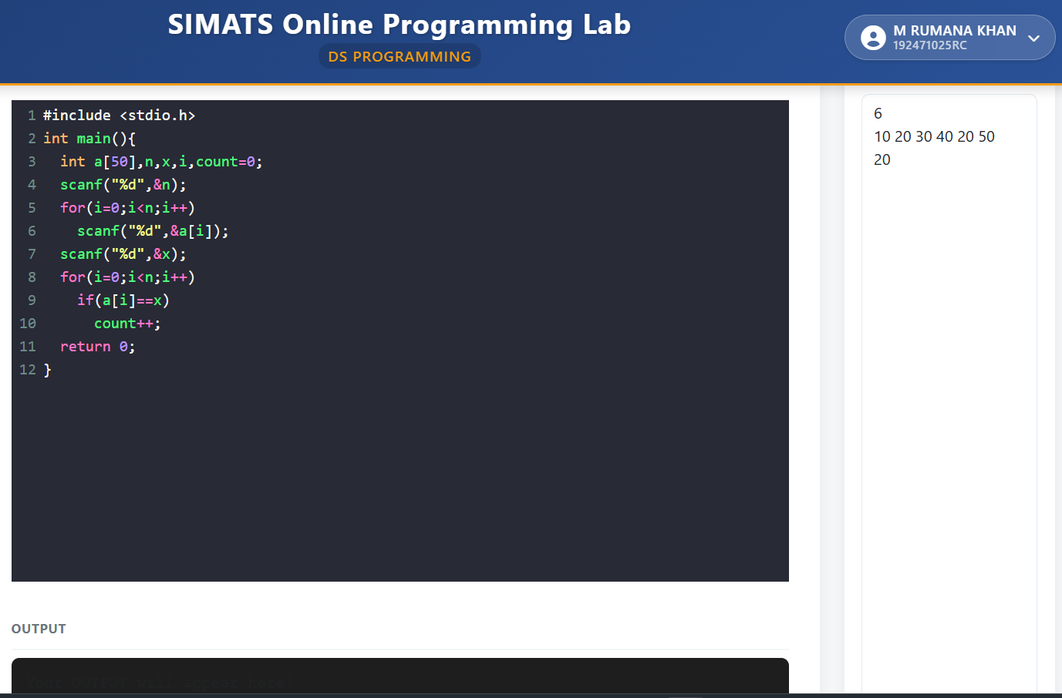

2. SEARCHING AN ELEMENT IN AN ARRAY:
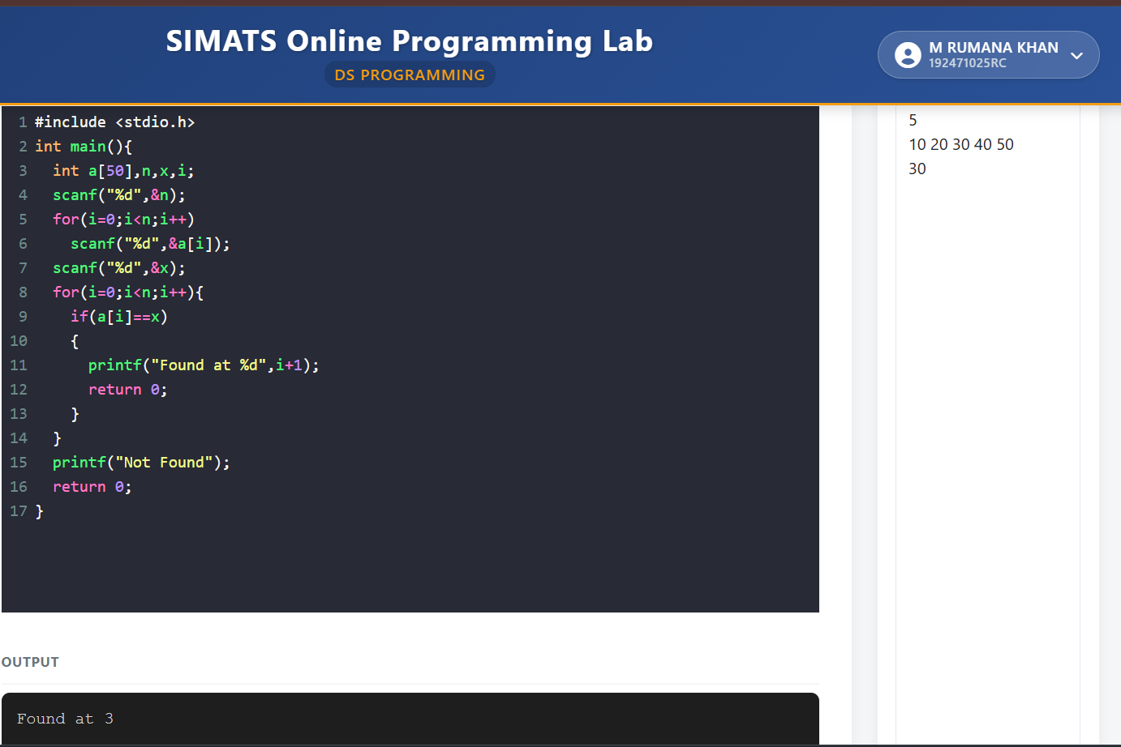

3. PALINDROME
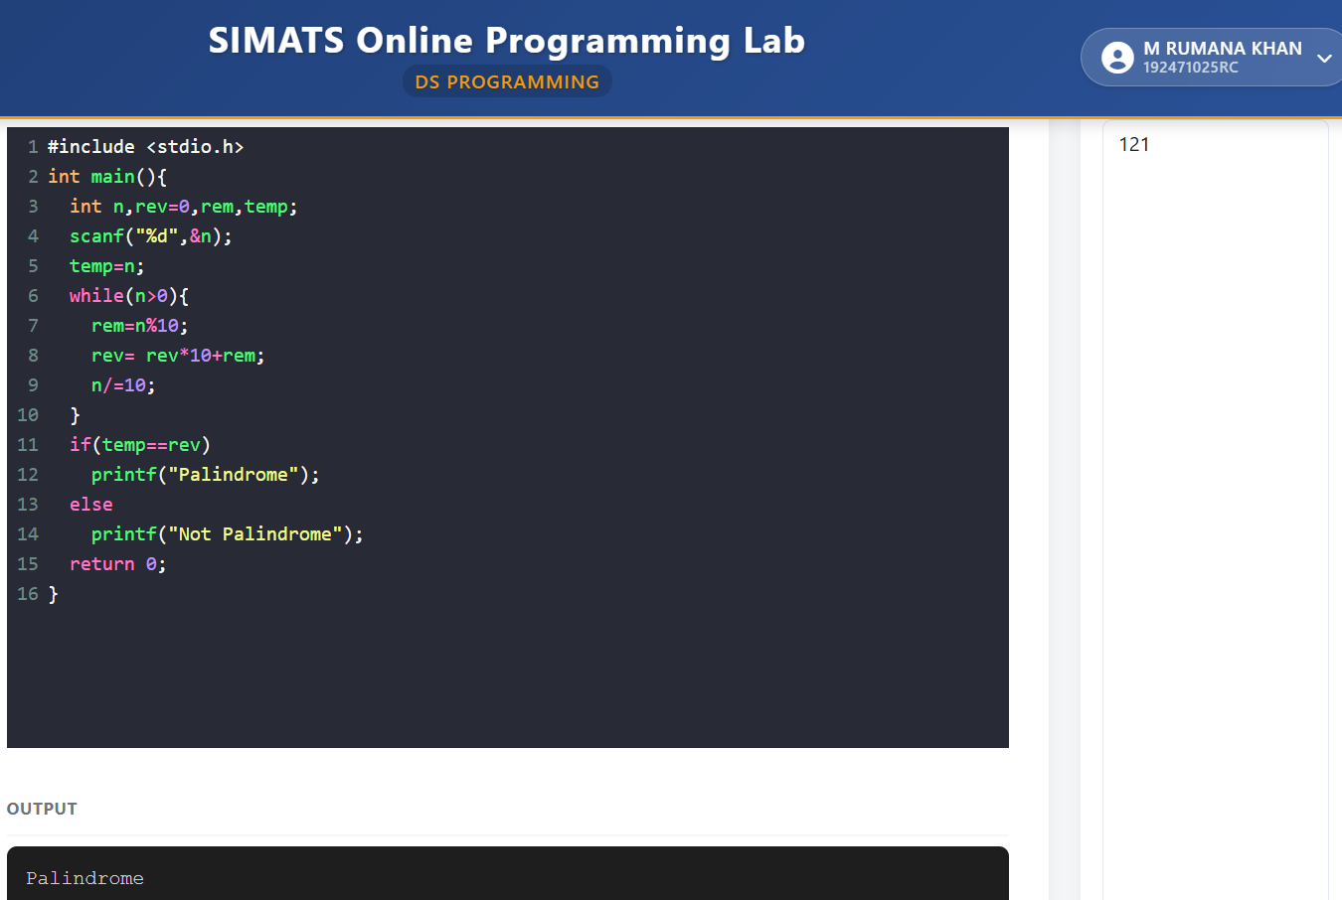

4. MERGING TWO SORTED ARRAYS:
